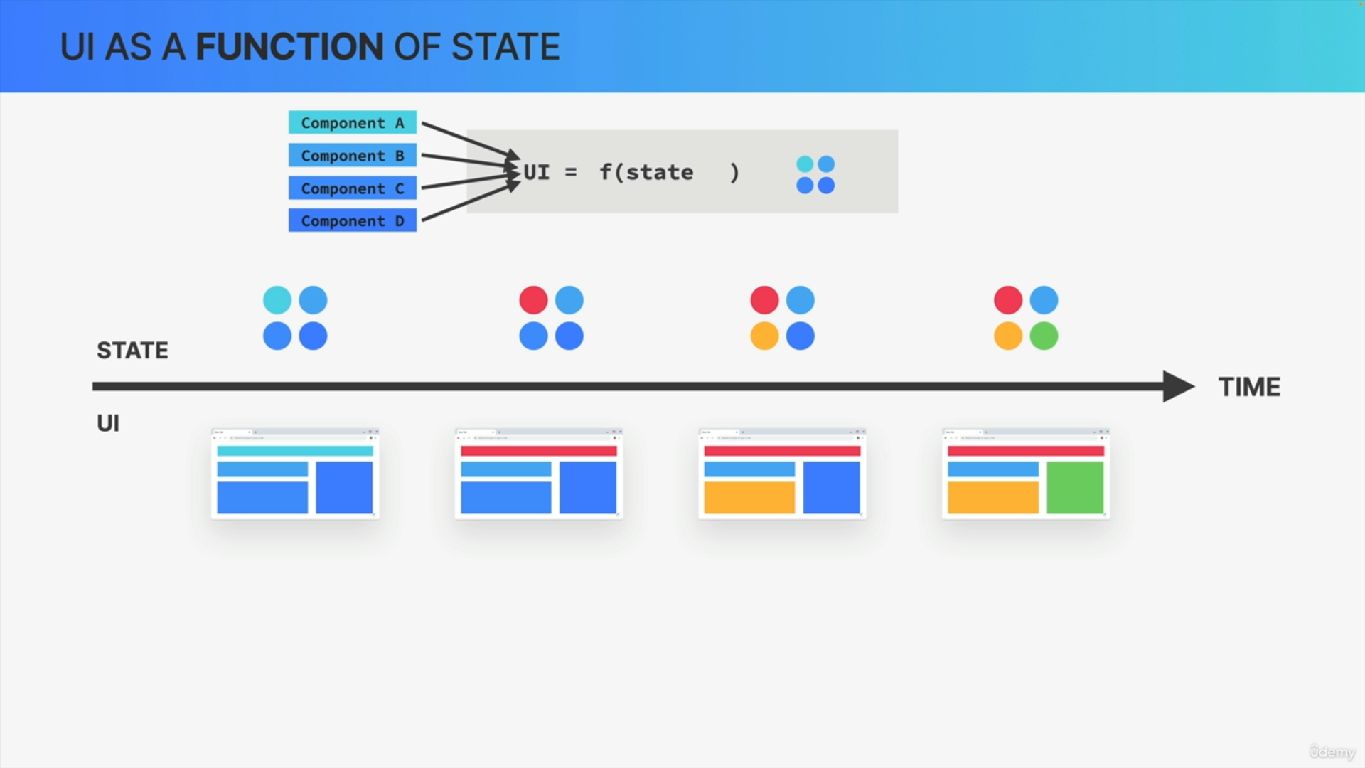

We can basically think of the entire application view, the entire user interface, as a function of state. In other words, the entire UI is always a representation of all the current states in all components.

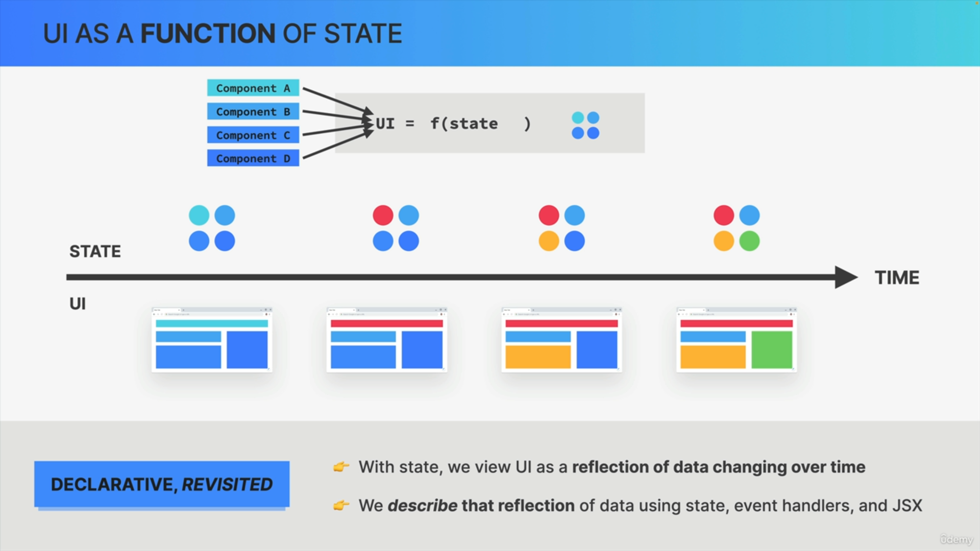

A React application is fundamentally all about changing state over time, and correctly displaying that state at all times.

This is really what the declarative approach to building user interfaces is all about. Instead of viewing a UI as explicit DOM manipulations, with state, we now view a UI as a reflection of data changing over time.

We describe that reflection of data using state, event handlers, and JSX.

